**The Việt Cộng - Citing Australians as “Vassals” - and as Australian “Aborigines”, in Phước Tuy Province**

Ernie Chamberlain – Research Note: January 2024

During the Vietnam War – and in the post-War period to date, Vietnamese communist writings and pronouncements invariably used pejorative terms when referring to Free World Forces involved in the Vietnam War and Sài Gòn Government troops. – including derogative pronouns and epithets (eg: *chúng nó, mấy, bọn*). The Australians were routinely referred to as “*chư hầu*” – ie “vassals” or “satellite troops of the US”; “mercenaries” (*quân đánh thuê*); and as “*bè lũ*” – “a gang”, “*giặc*” (“bandits”) and as “*xáo quy**ệt*” - ie “Machiavellian, tricky and devious”.

At times however, the effective military skills of Australian and New Zealand troops were noted by the communist writers – principally to further valorize the efforts of the NVA/VC against their better-equipped adversaries [1] and to highlight and add import and “kudos” to the communists’ claimed victories.

The 2006 Việt CộngĐất Đỏ District history also recorded that: “The Australians (most of whom were **aborigines/*thổ dân*** [2]) were very experienced mercenaries having fought a counter-guerilla war in Malaya. … They acclimatised to the weather and adapted to the tropical jungle terrain. They could cut through the thick, thorny jungle and would hide in the swamps and marshes – lying in ambush for many days at a time. … split up into many small elements, and using commando tactics, they ambushed our movement corridors, or followed our tracks deep into our bases. … . The Australians’ tricks regularly evolved. Their helicopters flew low, landing each of their commando groups close to the edges of our bases – they would then cut through the jungle and secretly approach their objective, attacking into our bases or calling down very destructive artillery fire if their group was not strong enough for an assault. This resulted in many casualties among the revolutionary forces.”[3]

A 2016 article by the Australian War Memorial noted that 258 Aboriginal and Torres Strait Islander men served in Vietnam – including 61 national servicemen.[4] According to the Australian Department of Veterans’ Affairs in 2023, about 285 servicemen/women of Aboriginal or Torres Strait Islands ethnicity served in the Australian forces in Vietnam during the War – including seven men at the Battle of Long Tân in August 1966.

About 3,890 New Zealand (NZ) troops served in 1 ATF – and earlier in the NZ 161st Artllery Battery with the 173rd US Airborne Brigade in 1965-mid 1966, and with the NZATTV. At its peak in late 1968, the New Zealand military strength reached 548. “About 35% of V Force (all NZ Forces deployed to Vietnam) were Maori.”[5]

It is possible that Vietnamese villagers or Việt Cộng underground cadre saw groups of New Zealand Maori soldiers in the towns and villages and considered them to be *thổ dân* – ie Australian “aborigines”, hence the remark in the 2006 Việt Cộng Đất Đỏ District history noted above.

Disparaging and offensive slurs for the NVA/VC by Australian and US troops were not uncommon eg: “Nigel”, “nog”, dink, gooks, slopes … . These terms were also applied to other Vietnamese.

Corporal Vincent Roberts – 2 RAR/NZ, an Aboriginal serviceman, instructing a Vietnamese Bushman Scout in the use of the GPMG-60 machine gun, June 1970 – Route 15 area.

(AWM: FAI/70/0408/VN – copyright expired, ie in the public domain)

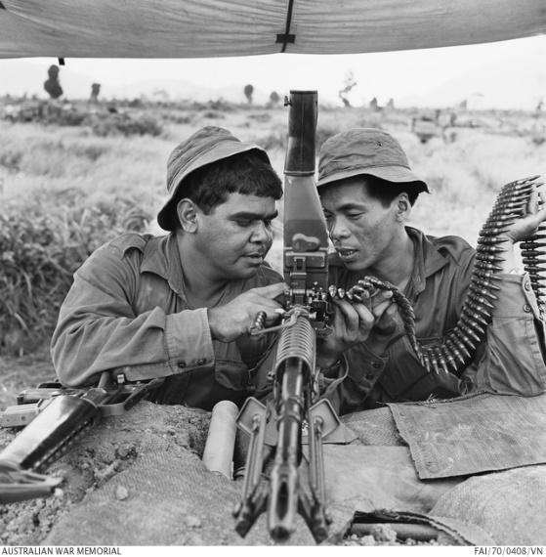

______________________________________________________________________

Extracted from Chamberlain, E.P., Research Note 1/2020, 28 February 2020 – Updated 2023: Communist Views of the 1st Australian Task Force (102 pages). Complimentary copies are available on request from [ernestchris@tpg.com.au](mailto:ernestchris@tpg.com.au) .

1. In Phước Tuy Province, 1 ATF had a significant technological military advantage over the local NVA/VC eg in: armour, artillery, tracked and wheeled mobility, helicopters and fixed-wing aircraft, communications, food supplies, shelter, and medical support. NVA/VC casualty rates were high, and life for the NVA/VC cadre and soldiers was very dangerous and difficult. Also - unlike Free World Force troops, NVA/VC cadre and soldiers had no defined/limited “tour of duty” during the War. See: Chamberlain, E.P., “Tougher Than Us – the NVA/VC” – Powerpoint presentation/Conference paper, Vietnam: International Perspectives on a Long War, Australian War Memorial, Canberra, 16 August 2013: Geelong Vietnam Veterans, 13 November 2013.
2. Đất Đỏ History – 2006, p.201. Literally – “*thổ dân*”. Trần Quang Toại & Đặng Tấn Hương (eds), Lịch Sử Đấu Tranh Và Xây Dựng Của Đảng Bộ, Quân Và Dân Huyện Đất Đỏ (1930-2005) (The History of the Struggle and the Building of the Party Chapter, the Forces and the Militia of Đất Đỏ District), Nhà Xuất Bản Tổng Hợp Đồng Nai (Đồng Nai Collective Publishing House), Biên Hòa, 2006. In southern Vietnam, the Châu Ro (Châu Râu) are a minority (ie an “aboriginal”) Mon-Khmer “Montagnard” ethnic group of about 26,800 – in 2009) of whom about 85% live in Đồng Nai, Bà Rịa and Long Khánh provinces. “*Thổ dân* – montagnards/*m**ọi* were derided by “low-land” Vietnamese (ie: *kinh*) – and the use of the term “*thổ dân*” for Australian troops appears to have been intended as a pejorative term. In 1967, about 150 Châu Ro were resettled by 1 ATF southward from the Slope 30 area of Route 2 to the Suối Nghệ hamlet of Bình Ba village. During the War, isolated groups of the Châu Ro minority remained under VC control in remote Xuyên Mộc District.
3. Trần Quang Toại & Đặng Tấn Hương (eds), The History of the Struggle and the Building of the Party Chapter, the Forces and the Militia of Đất Đỏ District, op.cit., Biên Hòa, 2006, p.201. See also Trần Văn Khánh (et al/*đtg*) and: Ban Chấp Hành Đảng bộ tỉnh Bà Rịa -Vũng Tàu (Executive Committee of the Bà Rịa-Vũng Tàu Party)**,** Lịch sử Đảng bộ tỉnh Bà Rịa-Vũng Tàu 1930 - 1975 (The History of the Party in Bà Rịa-Vũng Tàu Province 1930 1975), Nhà Xuất bản Chính trị Quốc gia (National Political Publishing House), Hà Nội, 2000, Chapter VII.
4. Riseman, N., “Between the Wars”, pp.38-43 in Wartime, Issue 76 – Spring 2016, Australian War Memorial, Canberra.
5. Lieutenant Colonel (Retd) T. Howell, MC, Jungle Green Shadows – Victor 2 Company, John Douglas Printers, Waikanae, 2019, p.95, p.294.