**Free Public Lecture**

**Building Australia’s Defence**

**Speaker: David Archibald**

**When: Saturday 25th January, 2025**

**Time: 2.30 pm start to 4.30 pm finish**

**Where: Padbury Hall, 2 Caley Road, Padbury**

The lecture, illustrated by more than 200 slides, covers the threat from China, lessons

from current wars, the moral rot in the ADF, fighter aircraft, submarines, artillery, drones, liquid fuel supply, the industrial base, nuclear energy, nuclear weapons, strategy and other weapons systems.

David Archibald is a prolific writer and author of books and articles. His contacts extend well beyond Perth having lectured in US Senate hearing rooms in 2011 & 2013. David has been a Visiting Fellow at the Institute of World Politics in Washington. He has been retained as an expert witness in the Supreme Court of NSW in the fields of petroleum geology and steel mills. He was successful in removing Brendan Grylls from the seat of Pilbara in the 2017 election.

David has drilled oil wells in the Canning Basin and conducted cancer research at Curtin University. His first two books were published at the suggestion of the lauded botanist Professor David Bellamy and the Czech President Vaclav Klaus respectively. David has lectured on cancer science and has had good results in advising on prostate cancer and peripheral neuropathy. His last book was entitled *The Anticancer Garden in Australia*. His second last book was on the F-35 and entitled *American Gripen: The Solution to the F-35 Nightmare*.

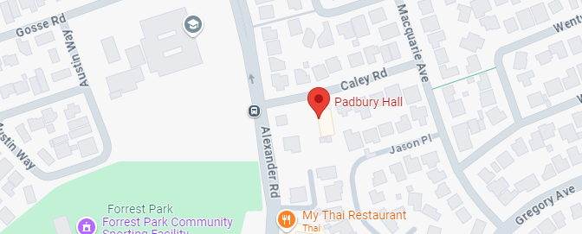

**Doors open: 2.00 pm**

**Authorised by: Peter Billington**